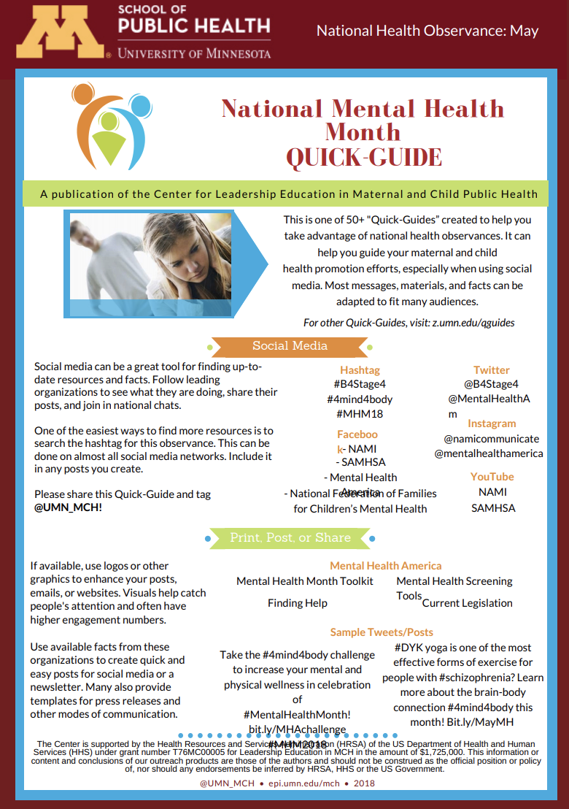
There are many national health observance days, weeks, or months. Observances can be used as opportunities to promote health messages, programs, and policies.
National Health Observance
Quick-Guides

Our 50+ “Quick-Guides” were created to help you take advantage of national health observances. They can help you guide your health promotion efforts, especially when using social media.

Most messages, materials, and facts can be adapted to fit many audiences.

Check out our video tutorial to review the Quick-Guides sections and learn how to use the Quick-Guides: z.umn.edu/qguides.

January:
National Stalking Awareness Month
National Drug Facts Week
Cervical Health Awareness Month
Folic Acid Awareness Week
Birth Defects Prevention Month

February:
American Heart Health Month
National Eating Disorders Awareness Week
Teen Dating Violence Awareness Month

March:
National Youth Violence Prevention Week
National School Breakfast Week
National Nutrition Month

April:
STI Awareness Month
Sexual Assault Awareness & Prevention Month
Minority Health Month
Autism Awareness Month
Every Kid Healthy Week
Contact Information
The Center for Leadership Education in Maternal & Child Public Health
Email: mch@umn.edu
Web: www.epi.umn.edu/mch
Distracted Driving Awareness Month
Alcohol Awareness Month

May:
Walk to School, Bike to School Day
National Teen Pregnancy Prevention Month
Healthy & Safe Swimming Week
National Mental Health Month
National Healthy Vision Month
Preeclampsia Awareness Month
Share & tag us! @umn_mch

National Hepatitis Awareness Month

June:
National Safety Month

August:
National Immunizations Awareness Month
National Breastfeeding Month

September:
National Suicide Prevention Month
Fruits & Veggies—More Matters Month
Ovarian Cancer Awareness Month
Sickle Cell Disease Awareness Month

October:
National Bullying Prevention Month

November:
National Diabetes Awareness Month

December:
World AIDS Day

